**Title:**

Impact of Humidity on Pallet Images

**Abstract:**

This session will focus on the creation and rationale behind compensating factors (F values) and how to utilize the knowledge for appropriate business use, as well as impact of those altered compression weights to testing results on corrugated materials. Additionally, special attention will be given to how the factor of humidity impacts the calculated compensating factors and what real-world situations should be considered when determining the variables for the calculation. The discussion will be centered around the risk, benefit, and strategy of utilizing custom compression calculations to fit individual business needs as well as presenting actual testing data from ISTA 3E testing using altered F values.

**Attendee Takeaways and Moderator Questions:**

* Reviewing the calculations to achieve custom F values using real-world examples and scenarios.
* Presenting test results from compression testing using increased compensating factors
* Presenting test results from compression testing with uncontrolled compared to controlled humidity conditioning.
* Discussing the impacts of humidity on compression strength and handling of pallets, including common real-world hazards in warehousing.

This session will focus on the impact of environmental conditions, such as humidity, on compression strength. The discussion will explore the complexity of the cold chain environments and how temperature handling can impact physical strength of pallet configurations, as well as the rationale behind compensating factors (F values) and how to utilize the knowledge for appropriate business use. Additionally, what is the risk, benefit, and strategy of utilizing custom compression calculations to fit individual business needs as well as presenting testing plans using altered F values to account for humidity concerns.

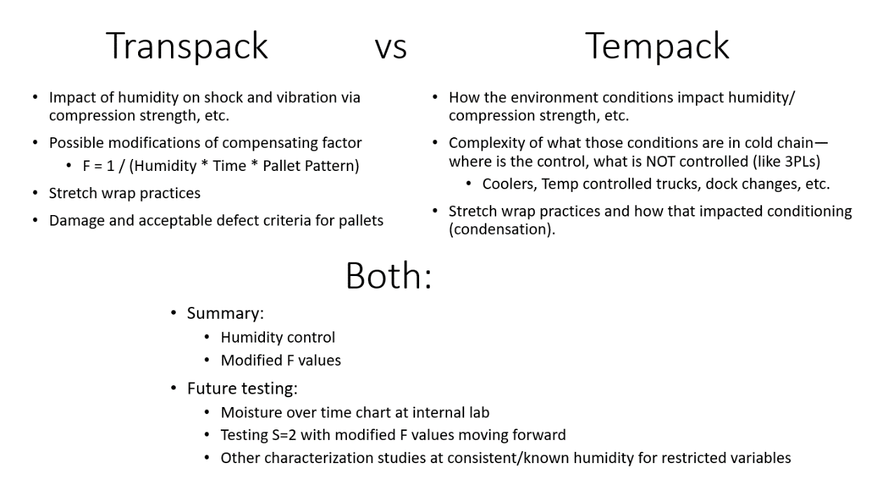

Plane: 500

Hotel: 900 (through ISTA)

Car: 200

Food: 150

Parking/Tolls: 128 + 20 + 20 = 168

Total Estimate: 1920